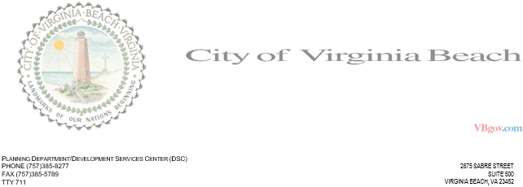

INTER-OFFICE MEMORANDUM **DATE:** 02/18/2021 **TO:** Some Recipient **FROM:** Travis **SUBJECT:** Some Project  
 DSC Engineering Review Comments  
 DSC File: Some Number

DSC cannot approve the project at this time. The following comments must first be addressed: